Kilbarchan A.A.C.
Outdoor Facility Risk Assessment

All athletes, coaches, officials, volunteers, meeting organisers, spectators and other users of Kilbarchan A.A.C. Outdoor Facility are to abide by the Kilbarchan A.A.C. Health and Safety Policy, Facility User Agreement and follow the instructions of the coaches, officials and/or meeting organisers.
In order to discharge the duty of care to provide a safe environment for training and competitions of track and field events at Kilbarchan Outdoor Facility, it is necessary to:-

- Identify hazards.
- Assess the associated risks.
- Take action to eliminate the hazard or failing this, take action to either eliminate the risks or reduce them, to an acceptable level.
Risks are assessed in terms of:-

- Low – No or minimal risk of injury.
- Medium – Some of risk of injury.
- High – High risk of injury.
Only where risks have been assessed as low, should training and/or competitions be allowed to take place. Where control measures are adequate and implemented then risks are categorised as low.
This risk assessment is broken down into the below disciplines that take place in Kilbarchan Outdoor Facility

- General area
- Track
- Throws
- Jumps
It is the responsibility of ALL coaches and athletes to ensure that all training sessions shall be conducted in a safe manner. The range of events, exercises and drills which athletes and coaches use is such that it would be impossible to specify each individually. Coaches must be aware particularly of the following ~

- Any risks attached to the event/exercise which an athlete is undertaking
- The age and skill level of the athlete
- The potential risks of using any equipment not specifically designed for the purpose it is being used for.
- Weather~ Should tracks, runways and throwing circles become covered in snow or ice or waterlogged then training should cease as risk would be HIGH
- All accidents to be reported to Trustees. Trustees will carry out investigation and make recommendations to improve safety.
The following schematic outlines the procedure to be followed ~

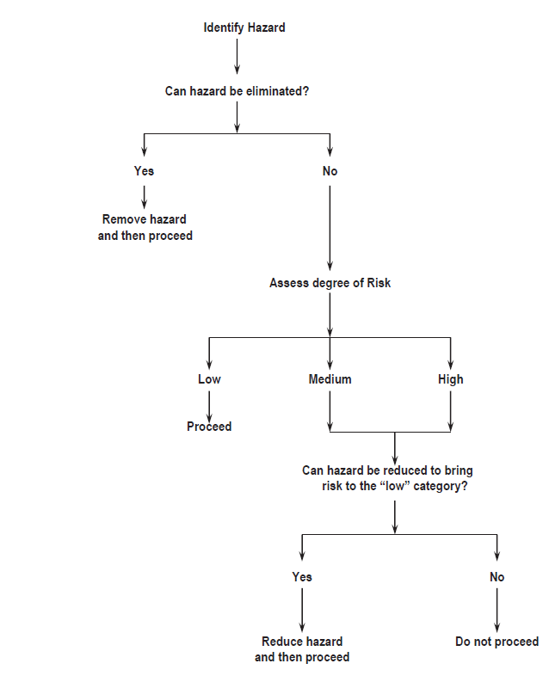
Coaches should be aware that they are responsible for the safety of their athletes not only during a training session at which they are present but also for the training set in training programmes which the athlete has been instructed to carry out.

Coaches should make it very clear to their athletes what training it is reasonable for them to do on their own and what training must be supervised.

Supervision of Training ~

- Young Athletes (under 18 years)
ALWAYS supervised by a qualified coach

- Junior Athletes (under 20 years or inexperienced senior athletes
- Supervised by a qualified coach
Events, including drills and exercises, which there is a risk of accidents to themselves or others.
- Unsupervised but with other athletes/coaches being present
Events, including drills and exercises, which have low risk of accidents to the athlete and others.
- Alone
Events, including drills and exercises, which are relatively risk free.

- Experienced Senior Athletes
- Supervised by a qualified coach
Events, including drills and exercises, which there is a risk of accidents to themselves or others.
- Unsupervised but with other athletes/coaches being present
Events, including drills and exercises, which have low risk of accidents to the athlete and others.
- Alone
Events, including drills and exercises, which are relatively risk free.

Weight Training
- Junior, younger and inexperienced senior athletes must be supervised at all times by a qualified coach
- Experienced senior athletes if unsupervised should always ensure that at least one other qualified coach or athlete is present

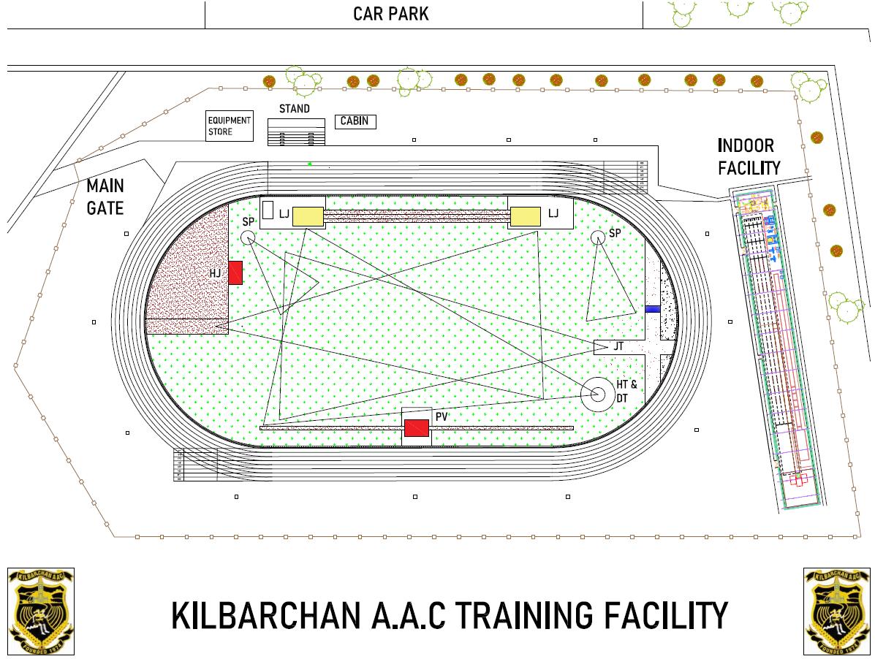
Outdoor Facility Areas
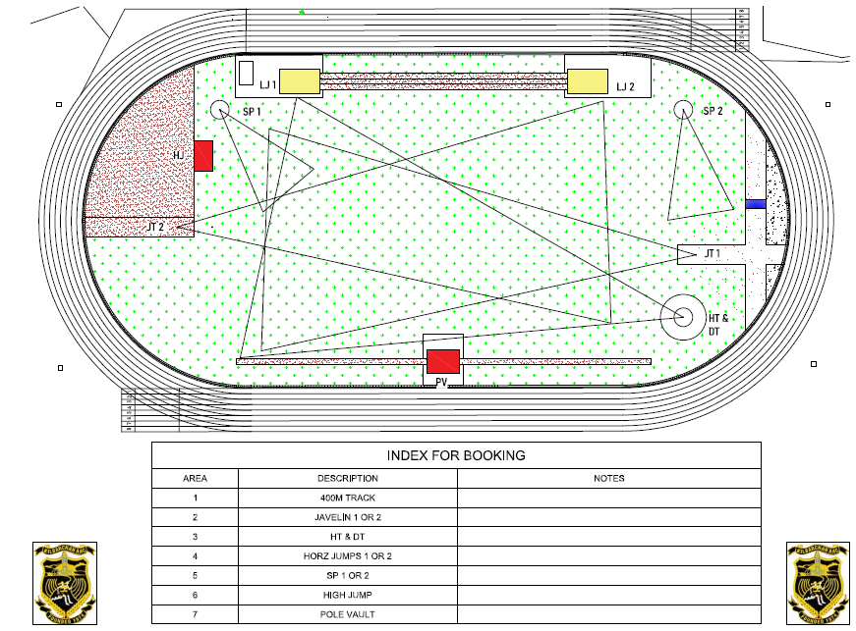
Risk Assessment: Kilbarchan A.A.C.

Date: | Assessed by: | Approved by: | Location : | Review :
19/01/2024 | Ricky Miell | Jim Goudie | Linwood Outdoor Facility | June 2024

Facility General

What are the Hazards? | Risk | People at risk | What are you already doing? | Risk Rating | What else can you do to control this risk? | Resultant Risk Rating | Action by whom | Completed
Qualification of coaches |  |  | - Coaching session ~ must be a minimum of level 2  - must have Children in Athletics Coaching Qualification & PVG | L | - If no minimum level 2 qualified coach ~ no session  - Register of coaches | L
Coach/athlete ratio |  |  | - SA ratios apply | L |  | L
Child Protection | Vulnerable users, U18 users | Users | - Coaches awareness of spectators  - SA coach to athlete ratio MUST be observed. No 1 to 1 coaching allowed without parent/guardian present | L | - Minimise spectators | L
People  participating who  are not eligible or  medically fit | Unknown medical conditions | Users | - Ensure users are eligible to participate  - Ensure users are medically fit to participate | M | - All users to sign user agreement form before access is allowed | L
Electrical sockets in cabin & span | Electrocution | Users | - Cover all sockets | H | - Ensure not misused by fixing for example bands to conduit  - Ensure all non-approved electrical devices removed | L
Equipment/  Obstructions | Slip, trips & falls | Users | - User to return all equipment to correct place after use  - First aid Kit kept in office | M | - Random check by Trustees  - Record incidents and inform users  - Access to qualified first aider | L
Equipment store untidy | Slips/trips/falls  Fire exit blocked | users | - Store all equipment in correct place | M | - Storage, shelves to be installed | L
What are the Hazards? | Risk | People at risk | What are you already doing? | Risk Rating | What else can you do to control this risk? | Resultant Risk Rating | Action by whom | Completed
Fire exits cabin/span | Equipment blocking path | Users | - Notice on door  - Fire exits and entrance to be kept clear of equipment, bags etc. | M | - Random check by Trustees  - Record incidents and inform users  - Add and record safety strips to doors | L
Fire evacuation procedures | Injury by heat/smoke or panic | Users | - Fire evacuation procedures on notice board  - Fire exits marked | M | - All coaches/athletes to familiarise themselves with procedures  - Fire plan to be updated | L
Lighting in cabin/span | Injury/trip/falls | Users | - Lights turned on for training sessions  - Report any broken lights | L | - Ensure session is done in adequate light | L
Warm up/cool down | Collisions  Injury/trip/falls | Athletes | - Athletes and coaches to observe lane discipline  - Only run in correct direction | M | - Any injuries to be recorded in accident book  - Report to be sent to KAAC welfare officer | L
Sport injuries |  | Athletes | - Any injuries to be reported to coach | L | - Report to be sent to KAAC welfare officer | L
Hot drinks | Scalding | Users | - No hot drinks allowed within training area  - Sports drinks only | L | - Report to be sent to KAAC welfare officer  - Any injuries to be recorded in accident book | L
Overcrowding |  | Users | - All sessions to be booked  - Refer to booking notes | L |  | L
Access to facility | Unauthorised access | Users | - All sessions to be booked for specific areas and times | L |  | L
Solo training | Lack of assistance due to injury/illness | Athlete | - Athlete to inform coach when session completed if no feedback key holder to be informed and investigate  - Coach to inform KAAC welfare | M | - Update user agreement  - Investigate possibility off of using QR code for sign in/out | L
Long throws & shot putt | injuries from thrown implements | Athletes/coaches | - If Any athlete can throw more than 30m only 1 long throw shall be allowed at training sessions. Separate booking times required. (as advised by SA) | M | • If long throws are being coached then coach to RA which shot putt area to be used. To be submitted to welfare before coaching session. | L

Area 1~Track

What are the Hazards? | Risk | People at risk | What are you already doing? | Risk Rating | What else can you do to control this risk? | Resultant Risk Rating | Action by whom | Completed
Loose track surface | Slips/trips/falls | Athletes | - Coaches to check track for loose track surface | L | - Report to trustees and record in book | L
Starting blocks | Slipping & tripping due to incorrect positioning or maintenance | Athletes | - Ensure blocks are firmly secured to track  - Ensure blocks are in good condition | L | - Blocks to be regularly inspected  - Report to trustees and record in book | L
Hurdles | Injuries from collision | Athletes | - Ensure ALL hurdles are removed from track after training  - Hurdles to face correct way  - Hurdle height to be set for correct age group  - Damaged hurdles not to be used | L | - Hurdles to be regularly inspected  - Report to trustees and record in book  - Check for other users and plan session to suit | L
Track kerb | Slips/tripping due to loose kerbing | Athletes | - Ensure adequate maintenance and inspection  - Kerbing removed for javelin etc. to be placed in safe area and replaced after event. | L | - Report broken kerbing to trustees | L
Weather | Strains from slipping on track | Athletes | - Ensure adequate maintenance and inspection  - Clean surface regularly to allow drainage | L | - Report any issues to trustees | L
Poor lighting conditions | Injury | Athletes | - Flood lights to used | L | - Report broken lights to trustees | L
Coaches and athletes on track | Injury | Athletes/coaches | - Athletes and coaches to observe track lane conditions  - Before run is about to start check track in both directions  - Run in an ant-clockwise direction | L | - Report any incidents to KAAC Welfare officer | L
Water jump | Injury | Athletes | - Ensure water is level with track surface  - Not to be used if empty  - Regularly inspect pit for debris and remove | L | - Report any issues to trustees  - Consider covering pit | L
Barriers | Injury | Athletes/coaches | - Check barriers for damage  - Carry out manual handling safe practice when placing/removing barriers  - Check adjustable barriers for correct and secure fixing of pins | L | - Report damage to trustees | L

Area 2 Javelin

What are the Hazards? | Risk | People at risk | What are you already doing? | Risk Rating | What else can you do to control this risk? | Resultant Risk Rating | Action by whom | Completed
Loose surface | Slips/trips/falls | Athletes | - Coaches to check surface for wear  - Ensure that runway is free of standing water, excessive dirt or grass cuttings. | L | - Report to trustees and record in book | L
Athletes/coaches not aware of throws commencing. | injuries from thrown implements | Athletes/coaches | - Coaches must ensure that other athletes or coaches within or in proximity of the throwing area are aware that a throw is due to commence. The coach must be satisfied that the throwing area, is clear and that any other persons appointed to mark landings or retrieve implements are fully aware a throw is about to progress. | M | - Area to be roped off | L
Athletes/coaches not aware of others | Injuries from thrown implements | Athletes/coaches | - Throws not to commence until coach sees that it is safe to do so | M | - Use of whistle to warn others | L
Damaged grip/bent javelin | injuries | Athletes/coaches | - Javelins must be checked before commencement of any throwing to ensure they are serviceable, particularly the grip and profile. | L | - Report any issues to trustees | L
Impact | Injuries | Athletes/coaches | - All throws must be from the runway and only in the direction of the sector  - Javelins are to be returned after throwing by carrying vertically and not by throwing  - During a throw, coaches and athletes must stand outside the sector lines, behind the thrower | L |  | L
Long throws | injuries from thrown implements | Athletes/coaches | - If any athlete can throw more than 30m only 1 long throw shall be allowed at training sessions. Separate booking times required if cage is being used. (As advised by SA) | L |  | L

Area 3 Hammer/Discus

What are the Hazards? | Risk | People at risk | What are you already doing? | Risk Rating | What else can you do to control this risk? | Resultant Risk Rating | Action by whom | Completed
Loose surface | Slips/trips/falls | Athletes | - Coaches to check surface for wear | L | - Report to trustees and record in book | L
Net not closed | Injuries from equipment | Athletes coaches | - Coaches to ensure net is closed  - Ensure a safe distance from netting to be maintained | M | - Session stopped until net corrected | L
Net poorly maintained | Injuries from hammer/shot | Athletes coaches | - Regular inspection of net | L | - Report to trustees and record in book | L
Circle | Falls due to unstable circle | Athletes | - Ensure circle is secured and undamaged  - Ensure surface is dry | L | - Report to trustees and record in book  - Session stopped until circle repaired | L
Equipment | Injury due to faulty equipment | Athletes | - Ensure athletes throw suitable object for age/ability | L |  | L
Athletes/coaches not aware of others | Injuries from thrown implements | Athletes/coaches | - Throws not to commence until coach sees that it is safe to do so | M | - Use of whistle to warn others | L
Athletes/coaches not aware of throws commencing. | injuries from thrown implements | Athletes/coaches | - Coaches must ensure that other athletes or coaches within or in proximity of the throwing area are aware that a throw is due to commence. The coach must be satisfied that the throwing area, is clear and that any other persons appointed to mark landings or retrieve implements are fully aware a throw is about to progress. | M | - Area to be roped off | L
Impact | Injuries | Athletes/coaches | - All throws must be from the cage and only in the direction of the sector  - During a throw, coaches and athletes must stand outside the sector lines, behind the thrower | L |  | L
Impact | Injuries | Athletes/coaches | - Check gates can move freely  - Gates to be set and adjusted for left and right throwers  - Ensure both gates are correctly positioned and locked before each throw | L |  | L
Falls | Injuries | Athletes/coaches | - Hammers caught in upper sections of net to be retrieved by competent person. Use ladders do not climb on cage | L |  | L
Long throws | Injuries from thrown implements | Athletes/coaches | - If any athlete can throw more than 30m only 1 long throw shall be allowed at training sessions. Separate booking times required (As advised by SA)

Area 4 Horz. Jumps

What are the Hazards? | Risk | People at risk | What are you already doing? | Risk Rating | What else can you do to control this risk? | Resultant Risk Rating | Action by whom | Completed
Loose track surface | Slips/trips/falls | Athletes | - Coaches to check track for wear  - Ensure run up area is regularly swept and mopped to | L | - Report to trustees and record in book | L
Debris in sand | Cuts/grazes | athletes | - Coaches to check sand before session  - Ensure area is free from all objects i.e. rakes etc. | L | - Report to trustees and record in book | L
Take off boards & blanking boards | Injury | Athletes  Coaches | - Boards checked for damage  - Boards checked to be stable & level to track  - Board lifting tool available and suitable for purpose | L | - Damaged boards removed to store  - Report to trustees and record in book | L
Landing area | Injury | Athletes | - Compacted sand to be dug over  - Landing area edges covered with soft material | L |  | L
Obstructions | Injury | Athletes | - Rakes and brushes are kept away from runway. Rakes laid with prongs down  - Athletes take their jumps in turn when instructed by coach | L |  | L
Athletes/coaches not aware of others | Injury | Athletes  Coaches | - Separate risk assessment to be completed by jump coach if throws training booked at same time | M | - Throws area to be roped off  - RA to be submitted to welfare before coaching session. | L
Area 5 Shot Putt

What are the Hazards? | Risk | People at risk | What are you already doing? | Risk Rating | What else can you do to control this risk? | Resultant Risk Rating | Action by whom | Completed
Loose surface | Slips/trips/falls | Athletes | - Coaches to check surface for wear | L | - Report to trustees and record in book | L
Circle | Falls due to unstable circle | Athletes | - Ensure circle is secured and undamaged  - Ensure drainage holes are clear  - Ensure surface is dry  - Ensure stop board is not damaged | L | - Report to trustees and record in book  - Session stopped until circle repaired | L
Equipment | Injury due to faulty equipment | Athletes | - Ensure athletes throw suitable object for age/ability  - All equipment to be checked before use | L |  | L
Athletes/coaches not aware of others | Injuries from thrown implements | Athletes/coaches | - Throws not to commence until coach sees that it is safe to do so | L |  | L
Athletes/coaches not aware of throws commencing. | injuries from thrown implements | Athletes/coaches | - Coaches must ensure that other athletes or coaches within or in proximity of the throwing area are aware that a throw is due to commence. The coach must be satisfied that the throwing area, is clear and that any other persons appointed to mark landings or retrieve implements are fully aware a throw is about to progress. | L |  | L
Impact | Injuries | Athletes/coaches | - All throws must be from the circle and only in the direction of the sector  - During a throw, coaches and athletes must stand outside the sector lines, behind the thrower | L |  | L
Impact | Injuries | Athletes/coaches | - If any long throws are being coached at same time then coach shall RA which shot putt area to be used. Safety sector to be roped off | M | - RA to be submitted to welfare before coaching session. | L
Sector | Injuries | Athletes/coaches | - Fill in holes in shot area after each session | L |  | L

Area 6 High Jump

What are the Hazards? | Risk | People at risk | What are you already doing? | Risk Rating | What else can you do to control this risk? | Resultant Risk Rating | Action by whom | Completed
Loose track surface | Slips/trips/falls | Athletes | - Coaches to check track for wear | L | - Report to trustees and record in book | L
Bars | Injuries | Athletes | - Check bar for damage  - Be aware of falling bar | L | - Report to trustees and record in book  - Remove bar to store | L
Landing covers | Injuries from sharp edges | Athletes | - Ensure no sharp edges or tears in covers | L | - Report to trustees and record in book | L
Elastic bar | Injuries from falling stands | Athletes | - Ensure stands are firmly secured  - Ensure elastic bar is sufficiently flexible | L |  | L
Landing bed | Injuries | Athletes | - Ensure regular inspection of bed  - Athletes should not wear jewellery which may cause injury  - No objects within 1m of sides and rear of bed | L | - Report to trustees and record in book | L
Stands | Injury from falling stand | Athletes | - Bases must be stable  - Ensure regular inspection | L | - Report to trustees and record in book | L

Area 7 Pole Vault (not in use at the moment)

What are the Hazards? | Risk | People at risk | What are you already doing? | Risk Rating | What else can you do to control this risk? | Resultant Risk Rating | Action by whom | Completed
Loose track surface | Slips/trips/falls | Athletes | - Coaches to check track for wear | L | - Report to trustees and record in book | L
Bars | Injuries | Athletes | - Check bar for damage  - Be aware of falling bar | L | - Report to trustees and record in book  - Remove bar to store | L
Landing covers | Injuries from sharp edges | Athletes | - Ensure no sharp edges or tears in covers | L | - Report to trustees and record in book | L
Elastic bar | Injuries from falling stands | Athletes | - Ensure stands are firmly secured  - Ensure elastic bar is sufficiently flexible | L |  | L
Landing bed | Injuries | Athletes | - Ensure regular inspection of bed  - Athletes should not wear jewellery which may cause injury  - No objects within 1m of sides and rear of bed | L | - Report to trustees and record in book | L
Stands | Injury from falling stand | Athletes | - Bases must be stable  - Ensure regular inspection | L | - Report to trustees and record in book | L
Vaults into sand | Cuts/grazes | Athletes | - Coaches to check sand before session  - Ensure area is free from all objects i.e. rakes etc. | L | - Report to trustees and record in book | L
Runs with pole | Slips/trips/falls | Athletes | - Ensure other coaches and athletes are aware of vaulters running | L |  | L
Vaults onto mats | Injury, mats too small, pole slipping | Athletes | - Ensure mats are thick enough and large enough  - Ensure the pole cannot slip | L |  | L
Poles | Injury, falling poles | Athletes | - Check all poles before use  - Beware of poles falling to side of landing area  - Ensure poles are stored where they do not cause a tripping hazard | L |  | L
Vaulting | Falls, collisions | Athletes | - Ensure other users are aware of vaulters on the run up  - Athletes should not wear jewellery which may cause injury | L |  | L
Landing area | Injury | Athletes | - Ensure regular inspection of bed  - Ensure beds are correct size and conforms to correct specification & rules | L | - Report to trustees and record in book | L
Box | Injury & pole damage |  | - Ensure regular inspection of box  - Ensure box is clearly visible |  | - Report to trustees and record in book
What are the Hazards? | Risk | People at risk | What are you already doing? | Risk Rating | What else can you do to control this risk? | Resultant Risk Rating | Action by whom | Completed
Stands | Injury from falling stand | Athletes | - Future equipment so N/A |  | - Winders and lower section of stands require protection  - Base to be well secured
Surrounds | Injury from falling onto hard surface | Athletes | - As above |  | - Any hard surface from centre of box~ 5m to front and sides & 7m to rear must be covered with suitable matting
Athletes/coaches not aware of others | Injury | Athletes  Coaches | - Separate risk assessment to be completed by pole vault coach if throws training booked at same time | M | - Throws area to be roped off | L

Risk Assessment Revision History

Date: | Assessed by: | Approved by: | Description : | Revision :
15/01/2022 | Ricky Miell | Jim Goudie | Original issue | O
19/01/2024 | Ricky Miell | Jim Goudie | Re-issued | 1

