Kilbarchan A.A.C.
Indoor Facility Risk Assessment

All athletes, coaches, officials, volunteers, meeting organisers, spectators and other users of Kilbarchan A.A.C. Indoor Facility are to abide by the Kilbarchan A.A.C. Health and Safety Policy, Indoor Facility User Agreement and follow the instructions of the coaches, officials and/or meeting organisers.
In order to discharge the duty of care to provide a safe environment for training and competitions of track and field events at Kilbarchan Indoor Facility, it is necessary to:-

- Identify hazards.
- Assess the associated risks.
- Take action to eliminate the hazard or failing this, take action to either eliminate the risks or reduce them, to an acceptable level.
Risks are assessed in terms of:-

- Low – No or minimal risk of injury.
- Medium – Some of risk of injury.
- High – High risk of injury.

Only where risks have been assessed as low, should training and/or competitions be allowed to take place. Where control measures are adequate and implemented then risks are categorised as low.
This risk assessment is broken down into the below disciplines that take place in Kilbarchan Indoor Facility:-

- 60m Track & hurdles
- Javelin
- Med Ball Wall
- Horz. Jumps
- Hammer/Shot Putt
- S & C
- Circuit & Plyo
- High Jump
- Pole Vault
It is the responsibility of ALL coaches and athletes to ensure that all training sessions shall be conducted in a safe manner. The range of events, exercises and drills which athletes and coaches use is such that it would be impossible to specify each individually. Coaches must be aware particularly of the following ~

- Any risks attached to the event/exercise which an athlete is undertaking
- The age and skill level of the athlete
- The potential risks of using any equipment not specifically designed for the purpose it is being used for.
- All accidents to be reported to Trustees. Trustees will carry out investigation and make recommendations to improve safety.

The following schematic outlines the procedure to be followed ~

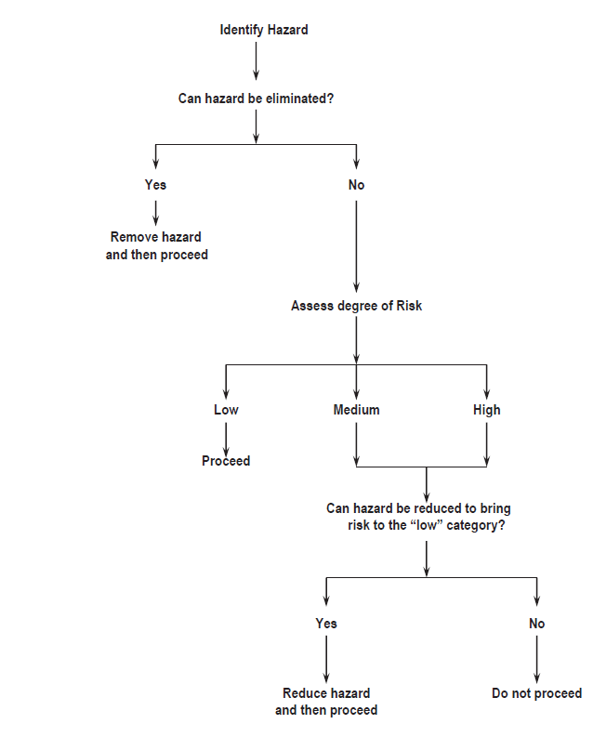
Coaches should be aware that they are responsible for the safety of their athletes not only during a training session at which they are present but also for the training set in training programmes which the athlete has been instructed to carry out.

Coaches should make it very clear to their athletes what training it is reasonable for them to do on their own and what training must be supervised.

Supervision of Training ~

- Young Athletes (under 18 years)
ALWAYS supervised by a qualified coach

- Junior Athletes (under 20 years or inexperienced senior athletes
- Supervised by a qualified coach
Events, including drills and exercises, which there is a risk of accidents to themselves or others.
- Unsupervised but with other athletes/coaches being present
Events, including drills and exercises, which have low risk of accidents to the athlete and others.
- Alone
Events, including drills and exercises, which are relatively risk free.

- Experienced Senior Athletes
- Supervised by a qualified coach
Events, including drills and exercises, which there is a risk of accidents to themselves or others.
- Unsupervised but with other athletes/coaches being present
Events, including drills and exercises, which have low risk of accidents to the athlete and others.
- Alone
Events, including drills and exercises, which are relatively risk free.

Weight Training
- Junior, younger and inexperienced senior athletes must be supervised at all times by a qualified coach
- Experienced senior athletes if unsupervised should always ensure that at least one other qualified coach or athlete is present
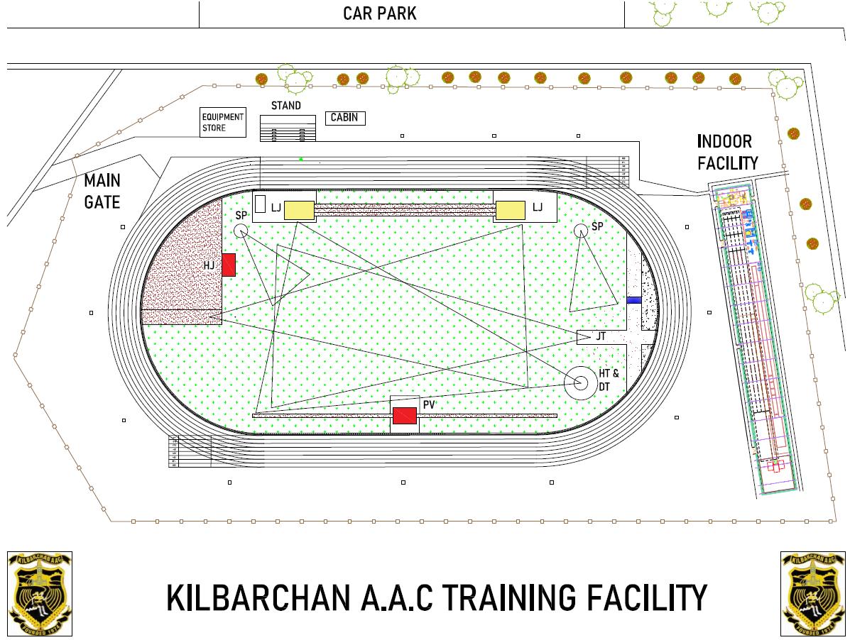
Indoor Facility Areas
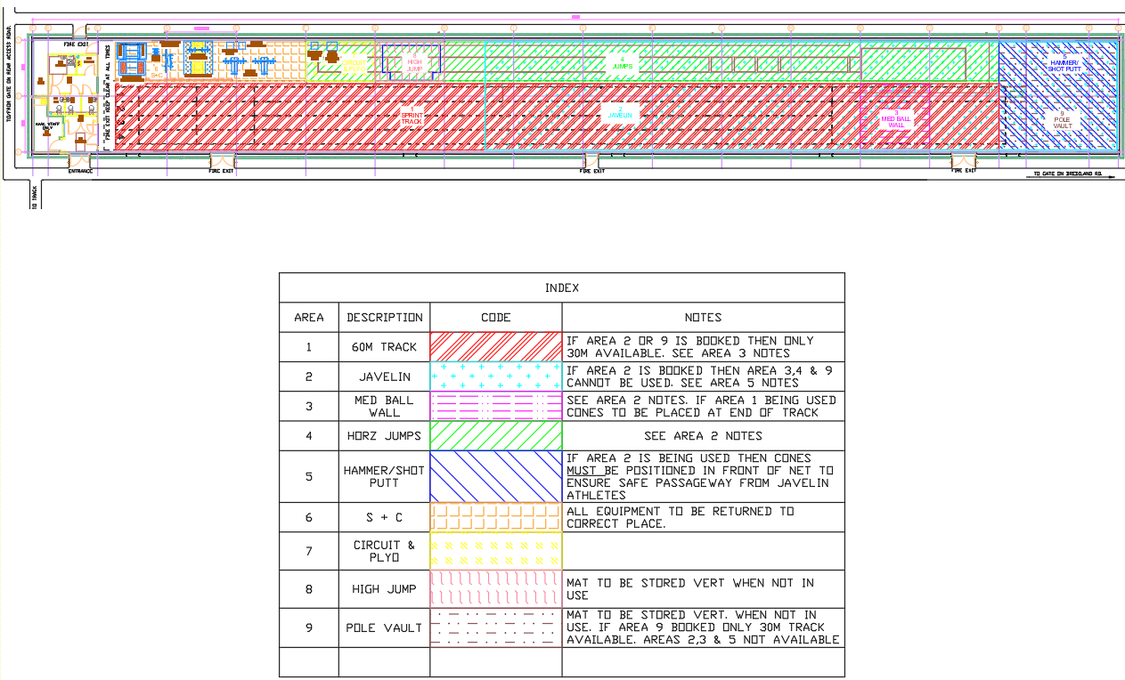

Risk Assessment: Kilbarchan A.A.C.

Date: | Revision | Assessed by: | Approved by: | Location : | Review :
19/01/24 | 2 | Ricky Miell | Jim Goudie | Linwood Indoor Facility | June 2022

Facility General

What are the Hazards? | Risk | People at risk | What are you already doing? | Risk Rating | What else can you do to control this risk? | Resultant Risk Rating | Action by whom | Completed
Qualification of coaches |  |  | - Coaching session ~ must be a minimum of level 2  - must have Children in Athletics Coaching Qualification & PVG | L | - If no minimum level 2 qualified coach ~ no session  - Register of coaches  - QR code to be used by all | L
Coach/athlete ratio |  |  | - SA ratios apply | L |  | L
Child Protection | Vulnerable users, U18 users | Users | - Coaches awareness of spectators  - SA coach to athlete ratio MUST be observed. No 1 to 1 coaching allowed without parent/guardian present | L | - Minimise spectators | L
People  participating who  are not eligible or  medically fit | Unknown medical conditions | Users | - Ensure users are eligible to participate  - Ensure users are medical fit to participate | M | - All users to sign user agreement form before access is allowed | L
Electrical sockets | Electrocution | Users | - Cover all sockets | H | - Ensure not misused by fixing for example bands to conduit  - Ensure all non-approved electrical devices removed | L
Equipment/  Obstructions | Slip, trips & falls | Users | - User to return all equipment to correct place after use  - First aid Kit kept in office | M | - Random check by Trustees  - Record incidents and inform users  - Access to qualified first aider | L
Alarm system |  |  | - Weekly check by ON-X staff | L | - Weekly check list to be signed | L
What are the Hazards? | Risk | People at risk | What are you already doing? | Risk Rating | What else can you do to control this risk? | Resultant Risk Rating | Action by whom | Completed
Fire exits | Used as access when athletes are running | Users | - Notice on door. NOT TO BE USED FOR ACCESS  - Fire exits and entrance to be kept clear of equipment, bags etc. | M | - Random check by Trustees  - Record incidents and inform users  - Add and record safety strips to doors | L
Fire evacuation procedures | Injury by heat/smoke or panic | Users | - Fire evacuation procedures on notice board  - Fire exits marked | M | - All coaches/athletes to familiarise themselves with procedures  - Fire plan to be updated | L
Lighting | Injury/trip/falls | Users | - Lights turned on for training sessions  - Report any broken lights | L | - Ensure session is done in adequate light | L
Warm up/cool down | Collisions  Injury/trip/falls | Athletes | - Athletes and coaches to observe lane discipline  - Fire exits, entrance & training area to be kept clear of equipment, bags etc. | M | - Any injuries to be recorded in accident book  - Report to be sent to KAAC welfare officer | L
Sport injuries |  | Athletes | - Any injuries to be reported to coach | L | - Report to be sent to KAAC welfare officer | L
Hot drinks | Scalding | Users | - No hot drinks allowed within training area  - Sports drinks only | L | - Report to be sent to KAAC welfare officer  - Any injuries to be recorded in accident book | L
Overcrowding |  | Users | - All sessions to be booked  - Refer to booking notes | L |  | L
Access to facility | Unauthorised access | Users | - All sessions to be booked for specific areas and times | L |  | L
Sound |  | users | - Music volume should not be loud. Athlete has to hear instructions clearly including to exit building in event of emergency | L | - Include background sound in fire plan | L

What are the Hazards? | Risk | People at risk | What are you already doing? | Risk Rating | What else can you do to control this risk? | Resultant Risk Rating | Action by whom | Completed
Solo training | Lack of assistance due to injury/illness | Athlete | - Athlete to inform coach when session completed if no feedback key holder to be informed and investigate  - Coach to inform KAAC welfare | M | - Update user agreement  - Investigate possibility off of using Bluetooth for sign in/out | L
Equipment store untidy | Slips/trips/falls  Fire exit blocked | users | - Fire exits and entrance to be kept clear of equipment and bags etc.  - Store all equipment in correct place  - Only store equipment and training items after Fire Exit within store. | M | - Storage, shelves to be installed  - Floor area local to fire exit to be marked “KEEP CLEAR AT ALL TIMES” | L

Area 1~Track

What are the Hazards? | Risk | People at risk | What are you already doing? | Risk Rating | What else can you do to control this risk? | Resultant Risk Rating | Action by whom | Completed
Loose track surface | Slips/trips/falls | Athletes | - Coaches to check track for loose track surface | L | - Report to trustees and record in book | L
Starting blocks | Slipping & tripping due to incorrect positioning or maintenance | Athletes | - Ensure blocks are firmly secured to track  - Ensure blocks are in good condition | L | - Blocks to be regularly inspected  - Report to trustees and record in book | L
Hurdles | Injuries from collision | Athletes | - Ensure ALL hurdles are removed from track after training  - Hurdles to face correct way  - Hurdle height to be set for correct age group  - Damaged hurdles not to be used | L | - Hurdles to be regularly inspected  - Report to trustees and record in book  - Check for other users and plan session to suit | L
Run off area | Slips/trips/falls | Athletes | - Ensure run off area is clear off obstructions  - Ensure concrete area has mats on floor to avoid slipping with spikes or easy up earlier to avoid concrete area | L | - Crash mats to be fitted if using full 60m | L

Area 2 Javelin

What are the Hazards? | Risk | People at risk | What are you already doing? | Risk Rating | What else can you do to control this risk? | Resultant Risk Rating | Action by whom | Completed
Loose surface | Slips/trips/falls | Athletes | - Coaches to check surface for wear | L | - Report to trustees and record in book | L
Net not used at 30m mark throwing in wrong direction | Injuries from javelin | Athletes coaches | - Coaches to ensure net is over full width of facility  - Ensure throws are towards throwing area | M | - Session stopped until net corrected | L
Net damaged | Injuries from javelin | Athletes coaches | - Netting to be checked before session | L | - Report to trustees and record in book  - If netting damaged session stops | L
Javelin | Injuries from javelin | Athletes coaches | - Safe distance from throwers to be maintained at side  - Check for loose or damaged grip  - Ensure suitable tip on javelin  - To be returned to store by carrying vertically | M | - Report to trustees and record in book  - Javelins to be checked before commencement of session | L
Impact from javelin | Injuries from javelin | Athletes coaches | - During a throw coaches and athletes must stand to the side wall  - Throws must not commence until instructed by coach | L |  | L
Gap from net to roof | Injuries from javelin | Athletes coaches | - Track, S+C, plyo. & HJ cannot be used  - Cones to be positioned at first line on track  - Notice “LONG THROWS IN PROGRESS” to MUST be put on entrance door to track | H |  | L
Area 2 & 5 being used at same time | Injuries from javelin | Athletes coaches | - Cones to be positioned for safe access to throw net

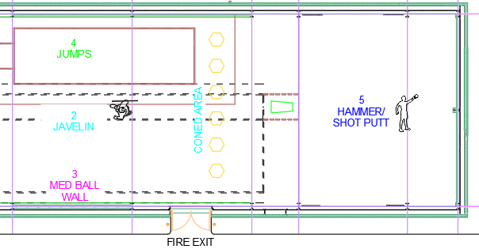
Area 3 Med Ball Wall

What are the Hazards? | Risk | People at risk | What are you already doing? | Risk Rating | What else can you do to control this risk? | Resultant Risk Rating | Action by whom | Completed
Loose wall surface | Slips/trips/falls | Athletes | - Coaches to check wall for damage | L | - Report to trustees and record in book | L
Impact from Med Ball | Injuries from Med Ball | Athletes coaches | - Safe distance from throwers to be maintained at side  - During a throw coaches and athletes must stand behind throwers  - Throws must not commence until instructed by coach | L | - Track to be coned off before wall to be for additional protection for track users | L
Med. balls | Injury | athletes | - Ensure med balls are in good condition | L | - Report to trustees and record in book | L

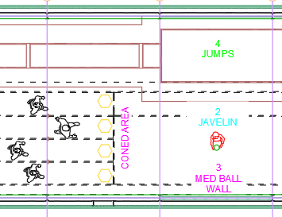

Area 4 Horz. Jumps

What are the Hazards? | Risk | People at risk | What are you already doing? | Risk Rating | What else can you do to control this risk? | Resultant Risk Rating | Action by whom | Completed
Loose track surface | Slips/trips/falls | Athletes | - Coaches to check track for wear | L | - Report to trustees and record in book | L
Debris in sand | Cuts/grazes | athletes | - Coaches to check sand before session  - Ensure area is free from all objects i.e. rakes etc. | L | - Report to trustees and record in book | L
Take off boards & blanking boards | Injury | Athletes  Coaches | - Boards checked for damage  - Boards checked to be stable & level to track  - Board lifting tool available and suitable for purpose | L | - Damaged boards removed to store  - Report to trustees and record in book | L
Landing area | Injury | Athletes | - Compacted sand to be dug over  - Landing area edges covered with soft material | L |  | L
Obstructions | Injury | Athletes | - Rakes and brushes are kept away from runway. Rakes laid with prongs down  - Athletes take their jumps in turn when instructed by coach | L |  | L

Area 5 Hammer/shot Putt

What are the Hazards? | Risk | People at risk | What are you already doing? | Risk Rating | What else can you do to control this risk? | Resultant Risk Rating | Action by whom | Completed
Loose surface | Slips/trips/falls | Athletes | - Coaches to check surface for wear | L | - Report to trustees and record in book | L
Net not closed | Injuries from equipment | Athletes coaches | - Coaches to ensure net is closed  - Ensure throws are towards throwing area and NOT towards other users on the track  - Ensure a safe distance from netting to be maintained | M | - Session stopped until net corrected | L
Net poorly maintained | Injuries from hammer/shot | Athletes coaches | - Regular inspection of net | L | - Report to trustees and record in book | L
Circle | Falls due to unstable circle | Athletes | - Ensure circle is secured and undamaged  - Ensure surface is dry | L | - Report to trustees and record in book  - Session stopped until circle repaired | L
Equipment | Injury due to faulty equipment | Athletes | - Ensure athletes throw suitable object for age/ability  - Ensure plastic or rubber equipment used | L |  | L
Walls & roof |  |  | - Ensure walls etc have suitable protection | L |  | L
Area 2 & 5 being used at same time | Injuries from javelin | Athletes coaches | - Cones to be positioned for safe access to throw net

Area 6 S & C

What are the Hazards? | Risk | People at risk | What are you already doing? | Risk Rating | What else can you do to control this risk? | Resultant Risk Rating | Action by whom | Completed
Loose surface | Slips/trips/falls | Athletes | - Coaches to check surface for wear | L | - Report to trustees and record in book | L
Equipment | Slips/trips/falls Injury | Athletes | - All equipment to be returned to racks  - Safety bars and pins to be used in squat rack  - Ensure correct adjustment of equipment is in place before any activity takes place  - Faulty equipment to be removed  - Ensure equipment is cleaned after use at all times  - Ensure area is clutter free  - Equipment only to be used in correct and appropriate manner | L | - Report to trustees and record in book | L
Use of S&C area | Injury | users | - U18 to be supervised at all times by suitably qualified coach. Refer to Supervision of Training section.  - Coaches require to be UKA level 3 or hold a certificate from recognised S&C NGB | M | - Users to complete induction  - External groups to RA their own activities and supply a copy to KAAC before using the S+C area | L
Lifting | Injury/death | users | - When using barbells minimum of 2 spotters required unless using the cage where safety bars are used correctly  - If solo lifting safety bars and pins MUST be used in squat cage at all times | L |  | L

Area 7 Circuit & Plyo

What are the Hazards? | Risk | People at risk | What are you already doing? | Risk Rating | What else can you do to control this risk? | Resultant Risk Rating | Action by whom | Completed
Loose track surface | Slips/trips/falls | Athletes | - Coaches to check surface for wear | L | - Report to trustees and record in book | L
Plyo boxes | Injuries | Athletes | - Ensure regular inspection of plyo boxes  - No objects within 1m of sides and rear of boxes | L | - Report to trustees and record in book  - Remove boxes to store | L
Mats | Injuries | Athletes | - Ensure regular inspection of mats | L | - Report to trustees and record in book  - Remove boxes to store | L
Equipment | Injuries | Athletes | - Ensure regular inspection of equipment | L | - Report to trustees and record in book  - Remove damaged equipment to store | L

Area 8 High Jump

What are the Hazards? | Risk | People at risk | What are you already doing? | Risk Rating | What else can you do to control this risk? | Resultant Risk Rating | Action by whom | Completed
Loose track surface | Slips/trips/falls | Athletes | - Coaches to check track for wear | L | - Report to trustees and record in book | L
Bars | Injuries | Athletes | - Check bar for damage  - Be aware of falling bar | L | - Report to trustees and record in book  - Remove bar to store | L
Landing covers | Injuries from sharp edges | Athletes | - Ensure no sharp edges or tears in covers | L | - Report to trustees and record in book | L
Elastic bar | Injuries from falling stands | Athletes | - Ensure stands are firmly secured  - Ensure elastic bar is sufficiently flexible | L |  | L
Landing bed | Injuries | Athletes | - Ensure regular inspection of bed  - Athletes should not wear jewellery which may cause injury  - No objects within 1m of sides and rear of bed | L | - Report to trustees and record in book | L
Stands | Injury from falling stand | Athletes | - Bases must be stable  - Ensure regular inspection | L | - Report to trustees and record in book | L

Area 9 Pole Vault

What are the Hazards? | Risk | People at risk | What are you already doing? | Risk Rating | What else can you do to control this risk? | Resultant Risk Rating | Action by whom | Completed
Loose track surface | Slips/trips/falls | Athletes | - Coaches to check track for wear | L | - Report to trustees and record in book | L
Bars | Injuries | Athletes | - Check bar for damage  - Be aware of falling bar | L | - Report to trustees and record in book  - Remove bar to store | L
Landing covers | Injuries from sharp edges | Athletes | - Ensure no sharp edges or tears in covers | L | - Report to trustees and record in book | L
Elastic bar | Injuries from falling stands | Athletes | - Ensure stands are firmly secured  - Ensure elastic bar is sufficiently flexible | L |  | L
Landing bed | Injuries | Athletes | - Ensure regular inspection of bed  - Athletes should not wear jewellery which may cause injury  - No objects within 1m of sides and rear of bed | L | - Report to trustees and record in book  - Confirm landing bed conforms to UKA specification | L
Stands | Injury from falling stand | Athletes | - Bases must be stable  - Ensure regular inspection | L | - Report to trustees and record in book | L
Vaults into sand | Cuts/grazes | Athletes | - Coaches to check sand before session  - Ensure area is free from all objects i.e. rakes etc. | L | - Report to trustees and record in book | L
Runs with pole | Slips/trips/falls | Athletes | - Ensure other coaches and athletes are aware of vaulters running | L |  | L
Vaults onto mats | Injury, mats too small, pole slipping | Athletes | - Ensure mats are thick enough and large enough  - Ensure the pole cannot slip | L |  | L
Poles | Injury, falling poles | Athletes | - Check all poles before use  - Beware of poles falling to side of landing area  - Ensure poles are stored where they do not cause a tripping hazard | L |  | L
Vaulting | Falls, collisions | Athletes | - Ensure other users are aware of vaulters on the run up  - Athletes should not wear jewellery which may cause injury | L |  | L
Landing area | Injury | Athletes | - Ensure regular inspection of bed  - Ensure beds are correct size and conforms to correct specification & rules | L | - Report to trustees and record in book | L
Box | Injury & pole damage |  | - Ensure regular inspection of box  - Ensure box is clearly visible |  | - Report to trustees and record in book
What are the Hazards? | Risk | People at risk | What are you already doing? | Risk Rating | What else can you do to control this risk? | Resultant Risk Rating | Action by whom | Completed
Stands | Injury from falling stand | Athletes | - Future equipment so N/A |  | - Winders and lower section of stands require protection  - Base to be well secured
Surrounds | Injury from falling onto hard surface | Athletes | - As above |  | - Any hard surface from centre of box~ 5m to front and sides & 7m to rear must be covered with suitable matting

Risk Assessment Revision History

Date: | Assessed by: | Approved by: | Description : | Revision :
7/06/21 | Ricky Miell | Jim Goudie | Original issue | O
13/12/21 | Ricky Miell | Jim Goudie | Responsibility, schematic and supervision of training pages added.  Overall facility plan added  Javelin ~ note re netting added | 1
19/01/25 | Ricky Miell | Jim Goudie | Various updates indicated in red | 2

