Sustrans 4.6 mile club handicap race
Exciting race with slowest starting first and the fastest chasing. Handicaps based on your park run times so you should finish together.
Trophy for first home.
Winners
Year | Winner | Net Time
2023 | ?
2022 | Stuart Fratson | 00:37:56
2019 | Michael McEwan | 00:27:20
2018 | Robert Snodgrass | 00:31:28
2017 | Jennifer Rooney | 00:32:57
2016 | Siobhan Inglis | 00:38:49
2015 | Norman Groves | 00:33:26
2014 | Max McFarlane | 00:46:06

Route Details
First athlete away at 7.30pm. Runners are asked to arrive just after 7.00pm. Pre-entry so handicaps can be worked out.
The route
Running on the cycle path and starts on the viaduct in Bridge of Weir and runs to the outside of Kilmacolm about turn and comes back to the start. Slight uphill slope first half and downhill for the return. There will be a volunteer waiting at the return point who you must go round behind him / her.
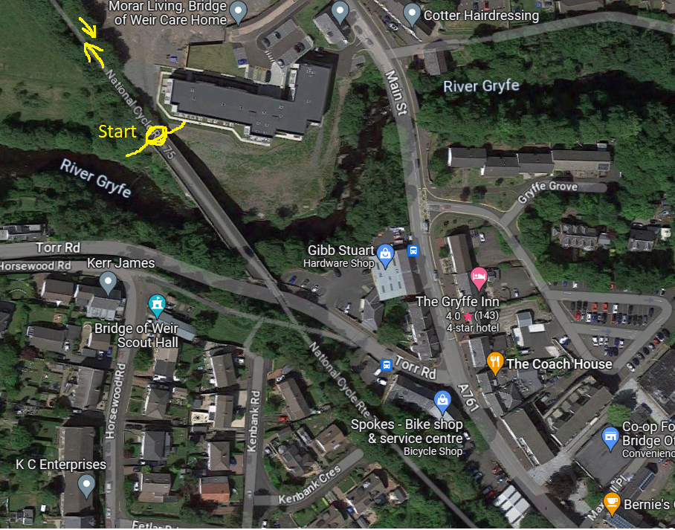

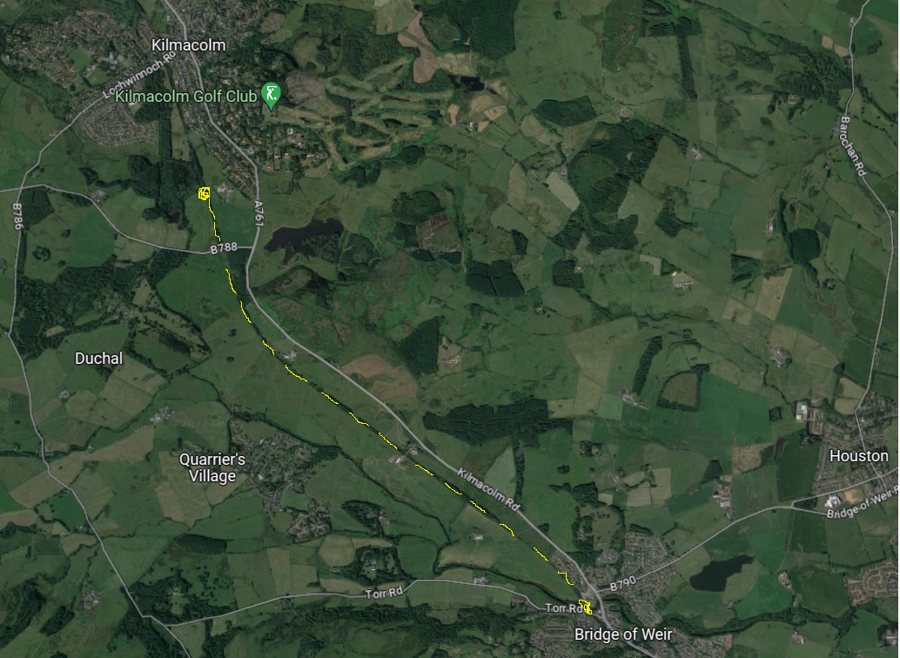

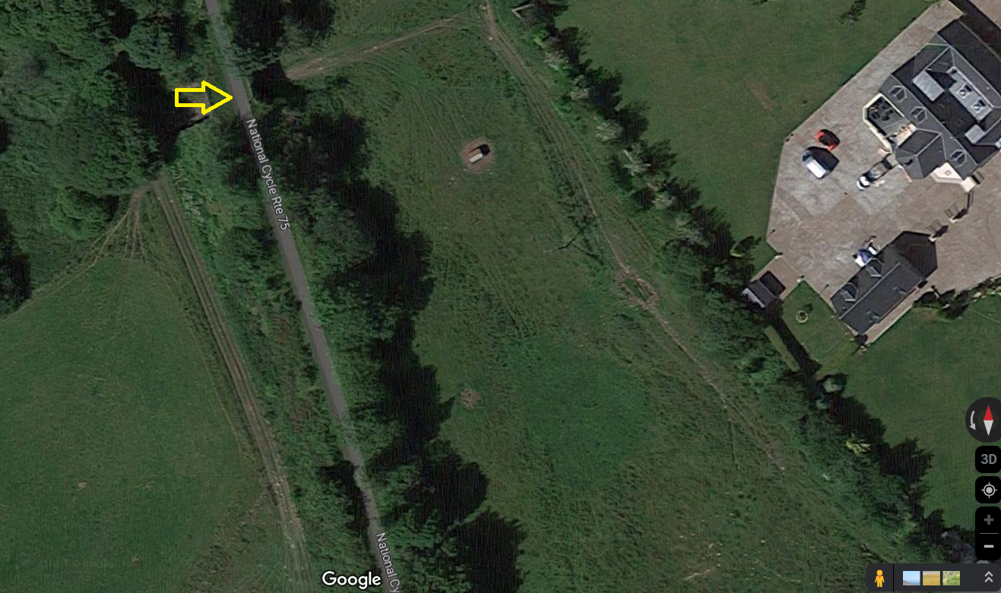
Turning point

